Fastcase Partner Marketing Assets
January

The following document contains marketing assets to share with your members. You are welcome to use the copy in any manner you want without obtaining our permission. We hereby grant you a non-exclusive right to reproduce, edit, publish, and reuse any material contained within this document.

We hope you enjoy the assets and find them a useful tool. This document is sent to all our bar association partners therefore we use the term [Your Bar Here] within our social media bytes so you can insert your organization’s name.

All images are optional additions to your posts. To use an image in a post, right-click on the image and select “Save to Keep.” A sidebar should pop up on the right and you can right-click the image and select “Save Image As.” Please send any suggestions, questions, and comments to marketing@fastcase.com.

We recommend posting the marketing content over the course of a few weeks. Feel free to use and distribute any of the content bytes in newsletters, tips, publications, videos, or whatever format you desire.

Click here for current logos and other marketing information.

Click here to view the Fastcase Quick Reference Guide for more tips and information on common uses.

The next marketing materials will be distributed in February.

Marketing Assets:

Post #1
Did you know [insert association] offers @Fastcase legal research as a free member benefit? Start researching today! Log in now and learn more at [insert association Fastcase page]

Post #2
Learn how to get the most out of your free access to Fastcase by watching a tour of Fastcase 7. Learn all the tips and tricks you need to enhance your legal research! https://www.youtube.com/watch?v=X574VjS7dUA
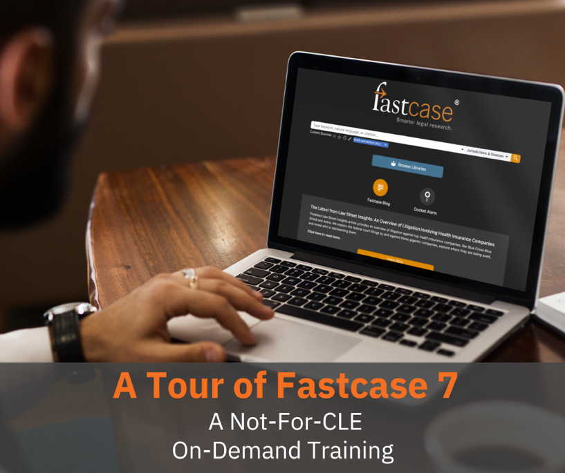

Post #3
Feature Update! @Fastcase recently launched the reorganization of the left-hand panel of the Jurisdiction picker. It’s now easier to choose states, federal, territories, and tribal. Log in to your member account to view now.
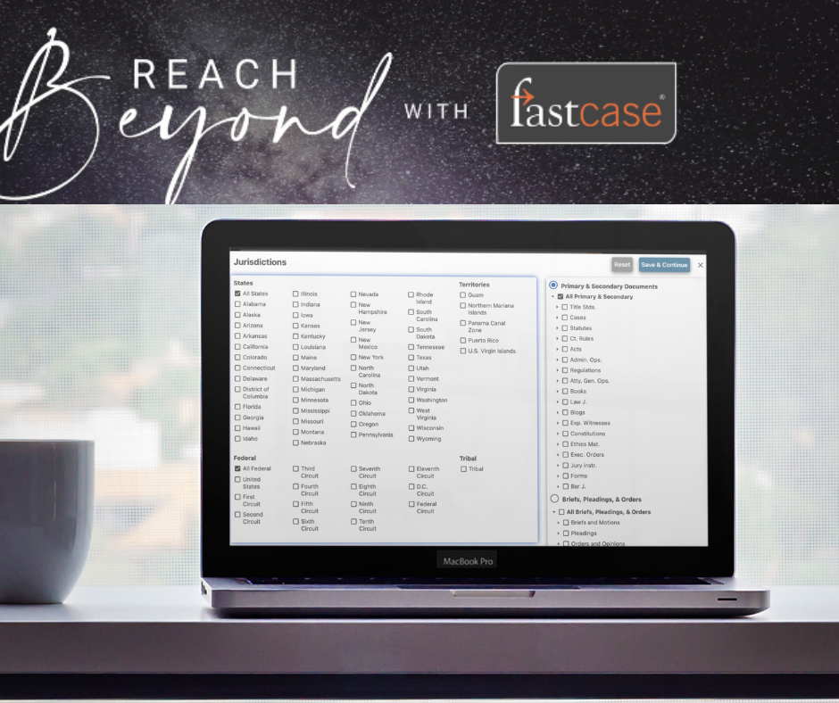

Post #4
Don't forget to check out @fastcase's bi-weekly Thursday webinars 🗓️ Whether you’re a new or experienced user, product experts will help you make sure you are getting the most out of your FREE access to Fastcase legal research. Register here: https://www.fastcase.com/webinars/

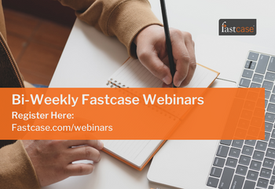

Post #5
Did you know you have access to Fastcase’s FREE legal news site @LawStreetMedia? Insights is a series of in-depth articles on Law Street Media, powered by cutting-edge Docket Alarm analytics. Each article elevates legal news by going beyond filings and statements to look at the data underpinning the companies, law firms, and trends affecting the legal world. Subscribe now: https://lawstreetmedia.com/lawstreetmedia.com/ls-subscribe-basic-1

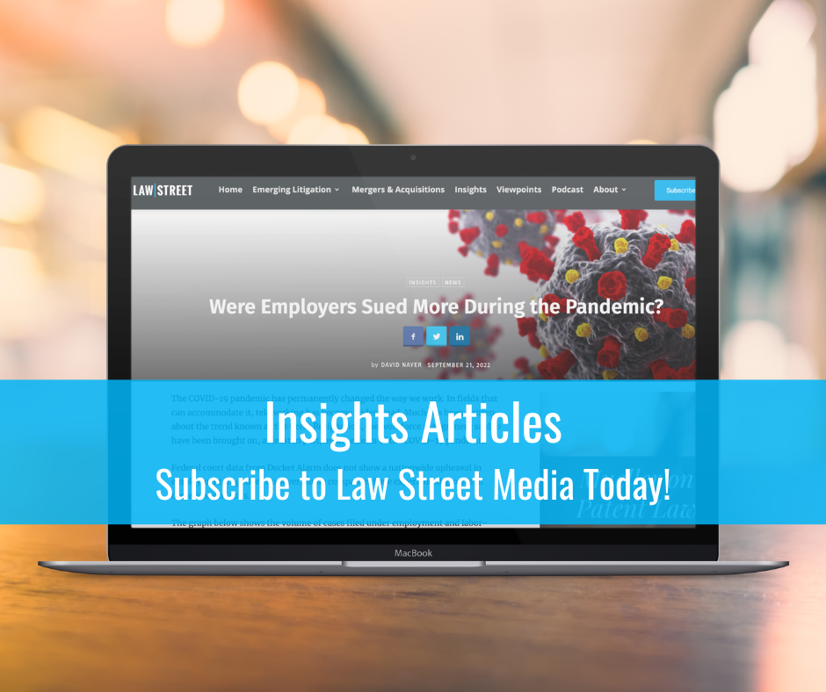

Post #6
Did you know that @fastcase's dataset has increased by more than half a BILLION documents? Provided by @DocketAlarm, users can now access hundreds of millions of briefs, pleadings, motions, and orders. Login now using your member account.
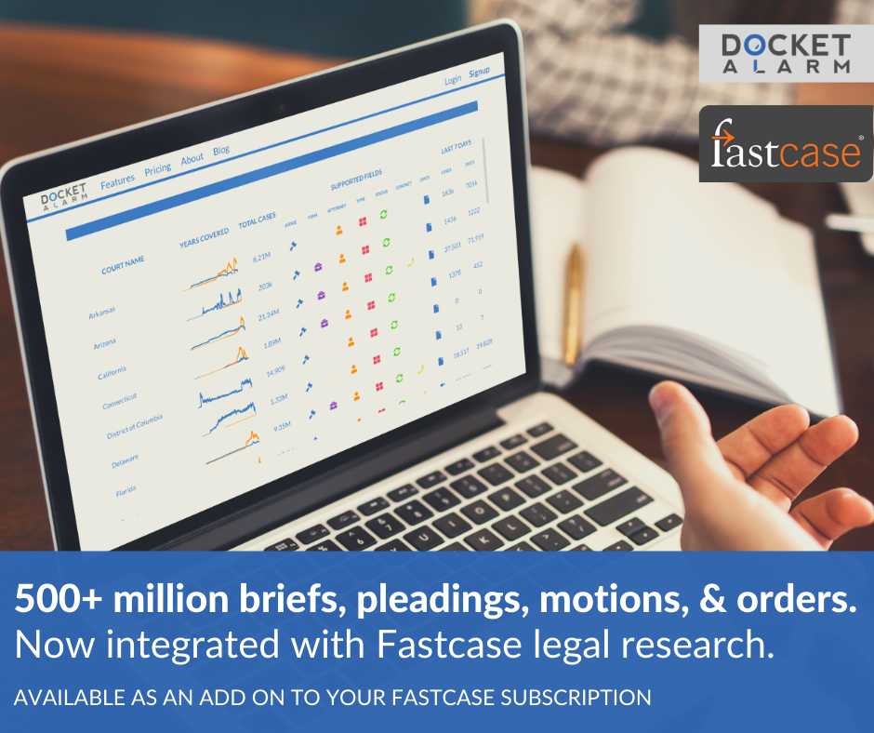

Post #7
Explore @fastcase’s powerful legal research tools by watching pre-recorded video tutorials. Learn more at: https://www.fastcase.com/support/ 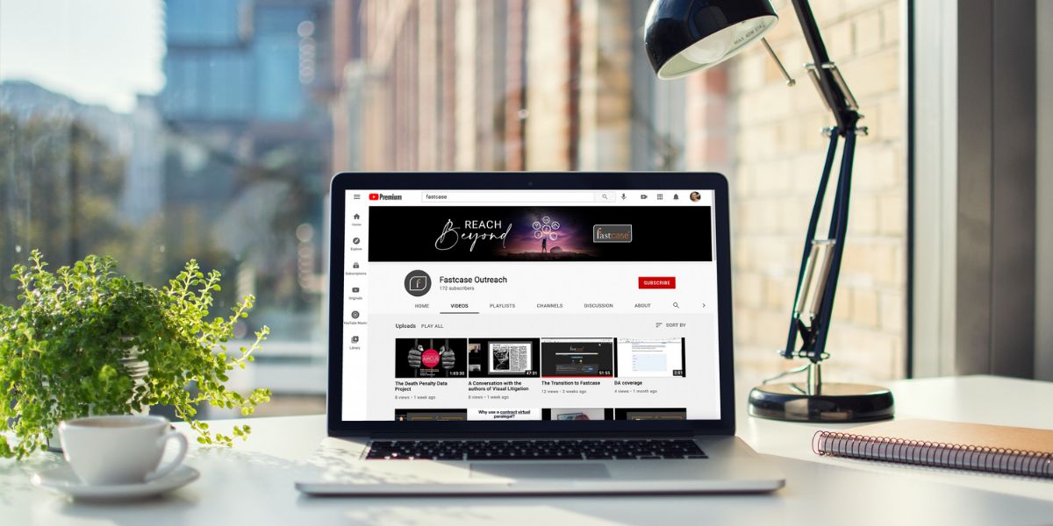

Post #8
The @fastcase support team is here to help with your legal research reference and technical questions. Contact Fastcase by email, using the LiveChat feature located on the Fastcase homepage, or by phone to speak with a reference attorney. https://www.fastcase.com/support/
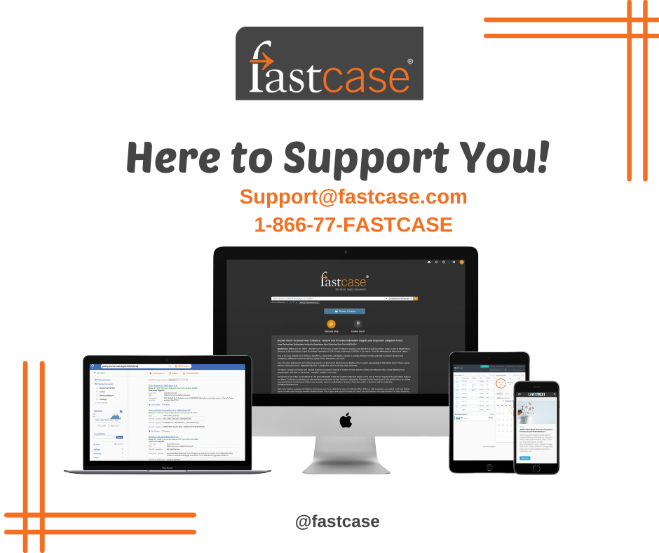

PLEASE DO NOT SHARE - For association use only
Non-CLE webinar recordings can be made available to any state association CLE team that wishes to offer free on-demand content. By utilizing this content on your side, we do ask for disclaimer information shared so that Fastcase will receive a list of individuals that utilize the content so we can monitor the utilization of these webinars and market future content when possible.

Specialty Webinars (Non-CLE)
Event Placeholder - If Fastcase is working directly with your association to provide a live event, this is the placeholder text to be used

Reminder to register for [event], where @fastcase will be presenting, “[title here]”: [insert registration link]

Upcoming Fastcase Webinars

Exploring Legal Research with Fastcase
Webinar Date: Thursday, January 12th, 2023
Webinar Time: 1:00 PM – 2:00 PM Eastern
Fastcase Overview CLE Handout

Mastering Advanced Legal Research Techniques
Webinar Date: Thursday, January 26th, 2023
Webinar Time: 1:00 PM – 2:00 PM Eastern
Fastcase Advanced CLE Handout Materials

Exploring Legal Research with Fastcase
Webinar Date: Thursday, February 9th, 2023
Webinar Time: 1:00 PM – 2:00 PM Eastern
Fastcase Overview CLE Handout

Mastering Advanced Legal Research Techniques
Webinar Date: Thursday, February 23rd, 2023
Webinar Time: 1:00 PM – 2:00 PM Eastern
Fastcase Advanced CLE Handout Materials

